CUSTOMER PURCHASE BEHAVIOUR ANALYSIS

Total Sales by Product Category
SELECT
ProductCategory,
SUM(TotalAmount) AS total_sales
FROM customer_purchase_data
GROUP BY ProductCategory
ORDER BY total_sales DESC;
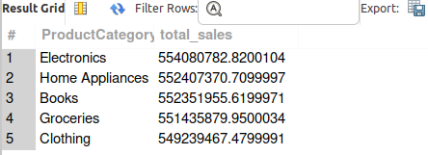

Average Spending per Customer
SELECT
CustomerID,
AVG(TotalAmount) AS avg_spending
FROM customer_purchase_data
GROUP BY CustomerID
ORDER BY avg_spending DESC;
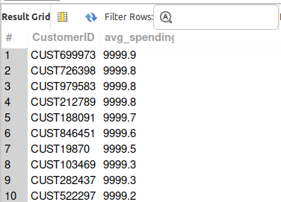

Number of Transactions per Customer
SELECT
CustomerID,
COUNT(*) AS total_transactions
FROM customer_purchase_data
GROUP BY CustomerID
ORDER BY total_transactions DESC;
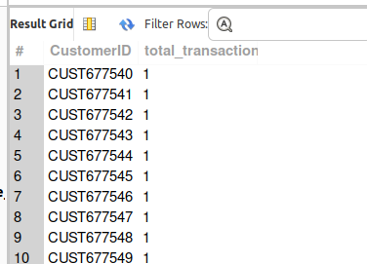

Average Price per Product Category

SELECT
ProductCategory,
AVG(Price) AS avg_price
FROM customer_purchase_data
GROUP BY ProductCategory
ORDER BY avg_price DESC;
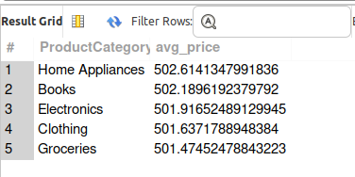

Basic Statistics
SELECT
MIN(Age) AS min_age,
MAX(Age) AS max_age,
AVG(Age) AS avg_age,

MIN(TotalAmount) AS min_amount,
MAX(TotalAmount) AS max_amount,
AVG(TotalAmount) AS avg_amount,

MIN(Price) AS min_price,
MAX(Price) AS max_price,
AVG(Price) AS avg_price,

MIN(Quantity) AS min_qty,
MAX(Quantity) AS max_qty,
AVG(Quantity) AS avg_qty
FROM customer_purchase_data;
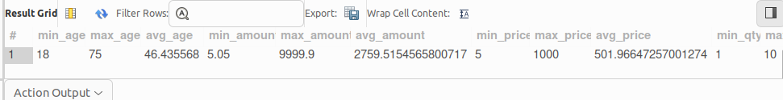

Age Distribution (Grouped)
SELECT
CASE
WHEN Age < 20 THEN 'Below 20'
WHEN Age BETWEEN 20 AND 30 THEN '20-30'
WHEN Age BETWEEN 31 AND 40 THEN '31-40'
WHEN Age BETWEEN 41 AND 50 THEN '41-50'
ELSE '50+'
END AS age_group,
COUNT(*) AS total_customers
FROM customer_purchase_data
GROUP BY age_group;

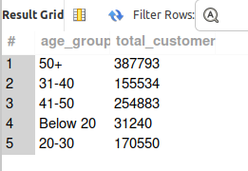

Spending Distribution

SELECT
CASE
WHEN TotalAmount < 100 THEN 'Low'
WHEN TotalAmount BETWEEN 100 AND 500 THEN 'Medium'
ELSE 'High'
END AS spending_group,
COUNT(*) AS transactions
FROM customer_purchase_data
GROUP BY spending_group;

SELECT
CASE
WHEN TotalAmount < 100 THEN 'Low'
WHEN TotalAmount BETWEEN 100 AND 500 THEN 'Medium'
ELSE 'High'
END AS spending_group,
COUNT(*) AS transactions
FROM customer_purchase_data
GROUP BY spending_group;
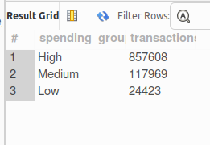

Quantity Distribution
SELECT
Quantity,
COUNT(*) AS freq
FROM customer_purchase_data
GROUP BY Quantity
ORDER BY Quantity;
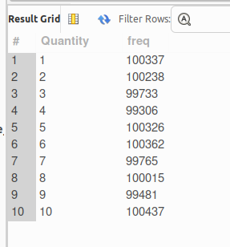

Total Spend per Customer
SELECT
CustomerID,
SUM(TotalAmount) AS total_spent
FROM customer_purchase_data
GROUP BY CustomerID;

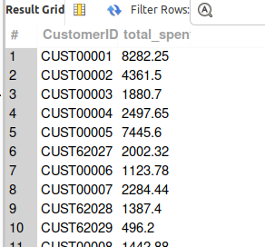

Customer Segmentation based on Spend
SELECT
CustomerID,
SUM(TotalAmount) AS total_spent,
CASE
WHEN SUM(TotalAmount) < 500 THEN 'Low Value'
WHEN SUM(TotalAmount) BETWEEN 500 AND 2000 THEN 'Medium Value'
ELSE 'High Value'
END AS customer_segment
FROM customer_purchase_data
GROUP BY CustomerID;
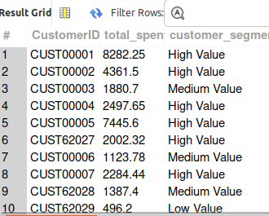

Monthly Sales Trend
SELECT
DATE_FORMAT(PurchaseDate, '%Y-%m') AS month,
SUM(TotalAmount) AS total_sales,
COUNT(*) AS total_orders
FROM customer_purchase_data
GROUP BY month
ORDER BY month;

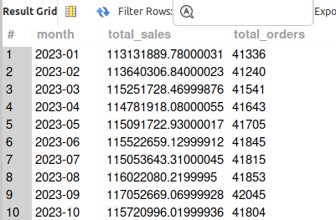

Quarterly Trend
SELECT
CONCAT(YEAR(PurchaseDate), '-Q', QUARTER(PurchaseDate)) AS quarter,
SUM(TotalAmount) AS total_sales
FROM customer_purchase_data
GROUP BY quarter
ORDER BY quarter;

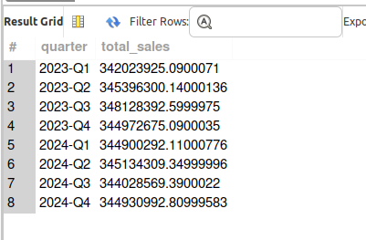

MOM growth
SELECT
month,
revenue,
LAG(revenue) OVER (ORDER BY month) AS prev_month_revenue,
ROUND(
(revenue - LAG(revenue) OVER (ORDER BY month))
/ LAG(revenue) OVER (ORDER BY month) * 100, 2
) AS mom_growth_percent
FROM (
SELECT
DATE_FORMAT(PurchaseDate, '%Y-%m') AS month,
SUM(TotalAmount) AS revenue
FROM customer_purchase_data
GROUP BY month
) t;
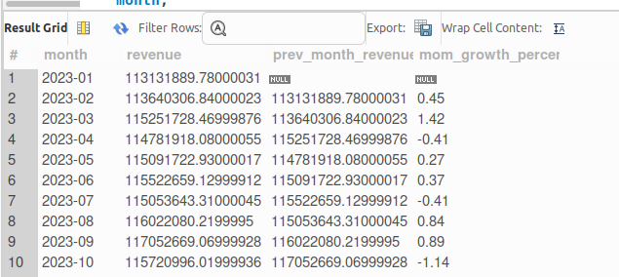

SELECT
year,
revenue,
LAG(revenue) OVER (ORDER BY year) AS prev_year_revenue,
ROUND(
(revenue - LAG(revenue) OVER (ORDER BY year))
/ LAG(revenue) OVER (ORDER BY year) * 100, 2
) AS yoy_growth_percent
FROM (
SELECT
YEAR(PurchaseDate) AS year,
SUM(TotalAmount) AS revenue
FROM customer_purchase_data
GROUP BY year
) t;
